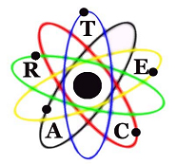
ARTEC Regional Professional-Technical Charter School
Michael Arrington, President Cheryle Becker, Vice President
Marie Sharp, Secretary-Treasurer

DIRECTORS
Nadia King Dale Layne Ron Anthony
Dr. L. T. Erickson Dr. Gaylen Smyer Dr. Ken Cox
Terry Patterson Cesar Perez

Advanced professional-technical education
preparing today’s students for success.
Regularly Scheduled Board of Directors Meeting Agenda
February 17, 2016
7:00 A.M. CSI Room 258 Taylor Building

- Call to Order – President Michael Arrington

Waive reading of the minutes of the previous board meeting as submitted to each board member.

- Approval of Agenda

- Consent Agenda
  - Approval of minutes January 20, 2016
  - Approval of bills as presented
  - Financial reports

- Reports
  - Dietrich Auto Body program – Brett Peterson
  - Annual plan of Improvement update – Mike & Claire
  - Administrative Search Committee update – Michael Arrington

- Action Items

- Next Meeting: March 16, 2016 7:00 a.m.

- Adjournment

