SCREAMS IN THE NIGHT!!!
Activity worksheet: Name:________________________

Key Vocabulary
Current | Flow of electrons – Symbol is I
Conductor | Material through which the current flows
Insulator | Material through which current does not flow
Resistance | Opposition to flow – Symbol is R
Resistor | Device which provides resistance
Volts | Pressure - Symbol is V
Ohms | Measure of resistance
Ohm’s Law | Relationship between voltage, current, and resistance. Calculates how they interact with each other. V=I*R

Draw and Label the Ohm’s Law Pyramid

V

I
R

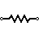 | 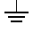 | 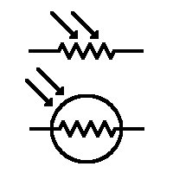 | +
Resistor | Ground | Photo-Resistor | Positive | Switch
Symbols

Resistance Table

Tape Resistor | Ohms

